**Assignment – NoSQL Basics & Fundamentals**

**1 –**

Import `travel-sample` bucket

->Go to settings->sample buckets

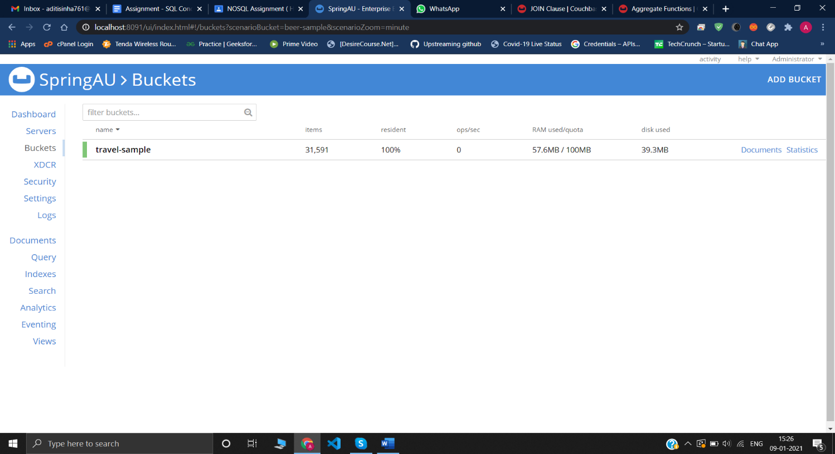

**2 –**Write a query to get the sum of all distances where type=”route” for each airline id.

SELECT airlineid ,Sum(distance) FROM `travel-sample`

WHERE type = "route"

GROUP BY airlineid;

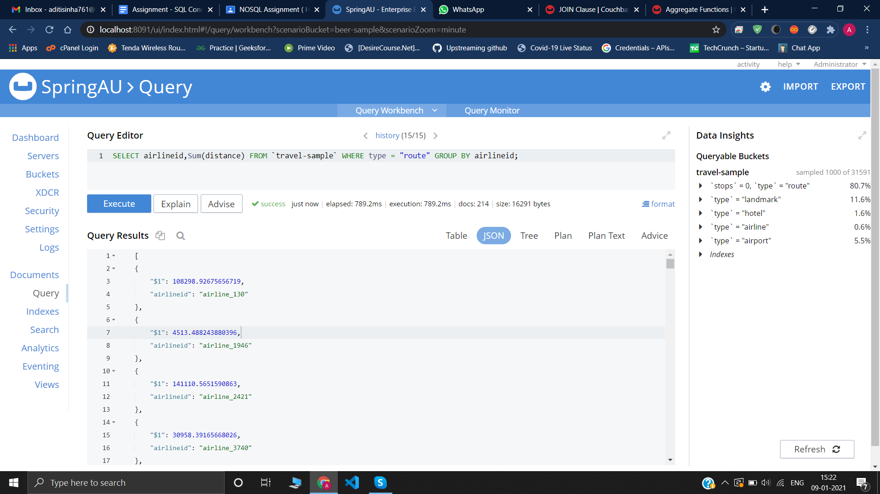

**3-**Write queries to join(LEFT,RIGHT,INNER) type=”route”&“airline” and fetch the data whose sourceairport=”SFO”

**// INNER JOIN**

SELECT *

FROM `travel-sample` route

INNER JOIN `travel-sample` airline ON META(airline).id = route.airlineid

AND airline.type = "airline"

WHERE route.sourceairport="SFO";

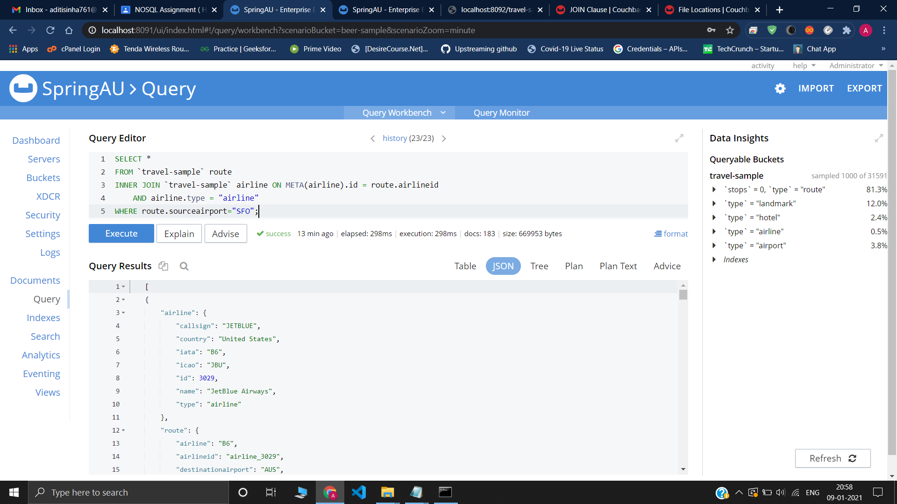

**//Right JOIN**

SELECT *

FROM `travel-sample` route RIGHT

JOIN `travel-sample` airline ON META(airline).id = route.airlineid

AND airline.type = "airline"WHERE route.sourceairport="SFO";

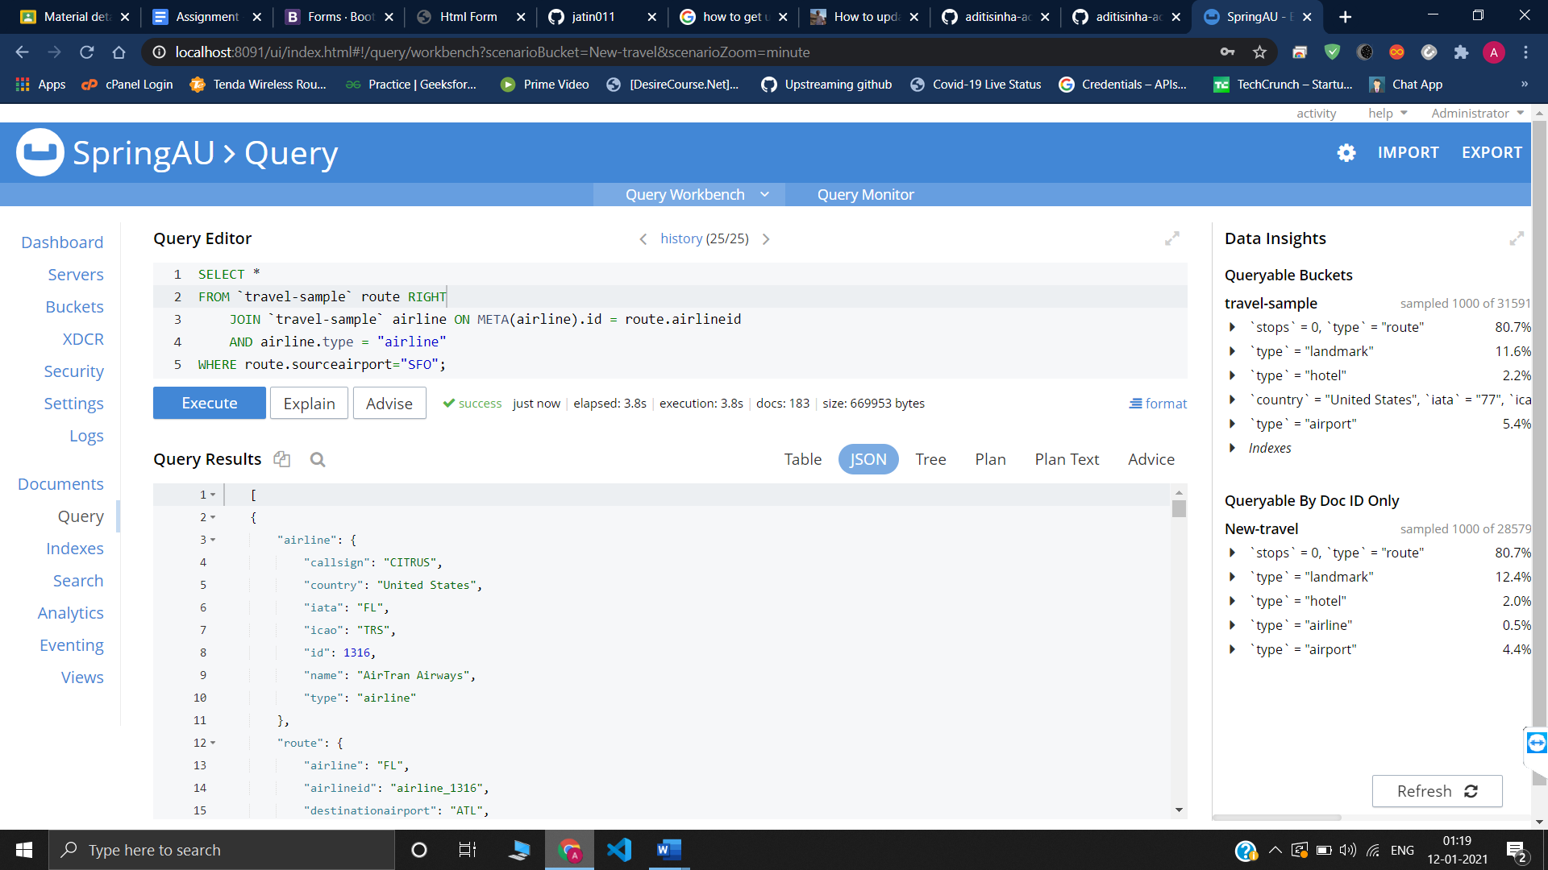

// **LEFT JOIN**

SELECT *

FROM `travel-sample` route LEFT

JOIN `travel-sample` airline ON META(airline).id = route.airlineid

AND airline.type = "airline"

WHERE route.sourceairport="SFO";

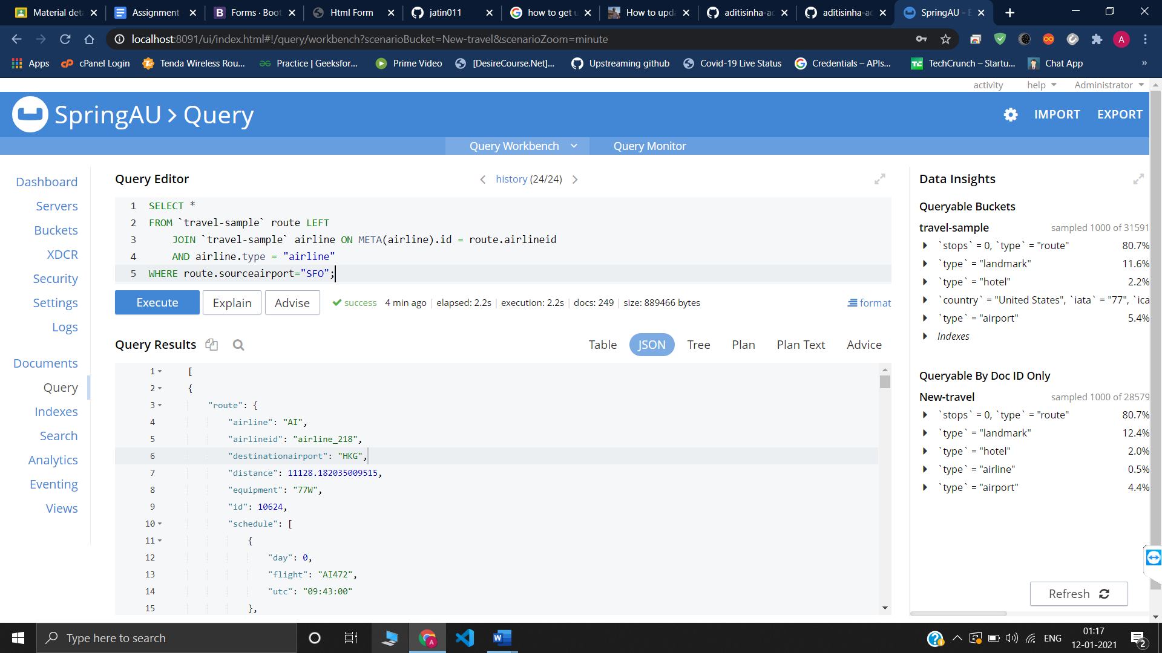

**4-** Write a mapreduce to get the number of all documents based on entities(type).

**Map**

function (doc, meta) {

emit(doc.type);

}

**Reduce**

_count

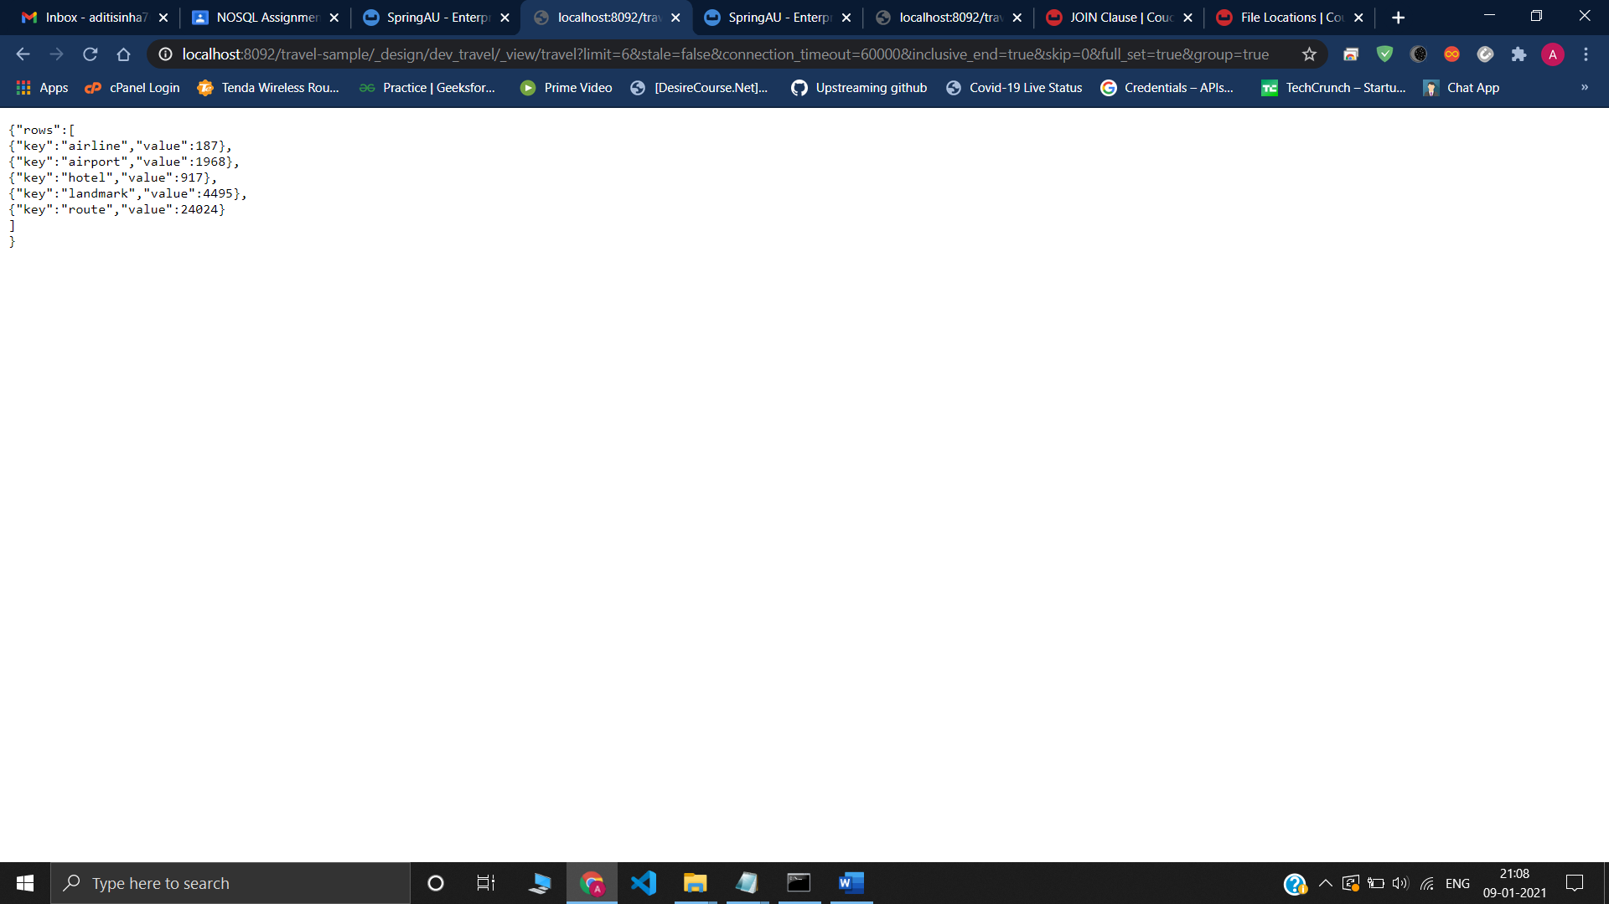

**5-**

Cmd command used to export or import data

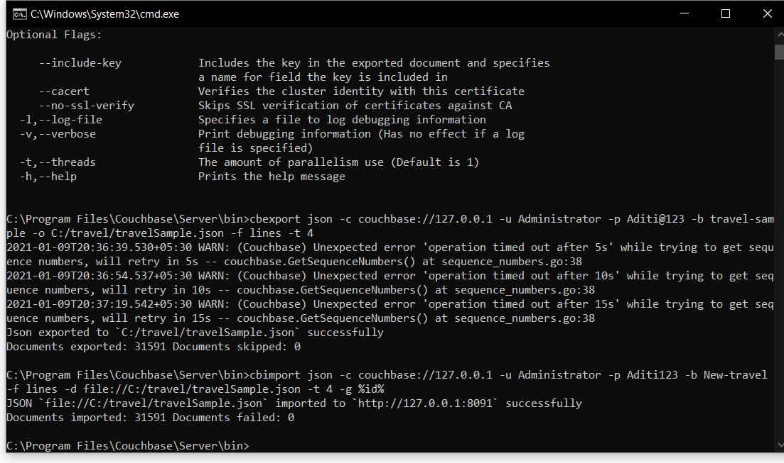

Document of travel-sample which is exported

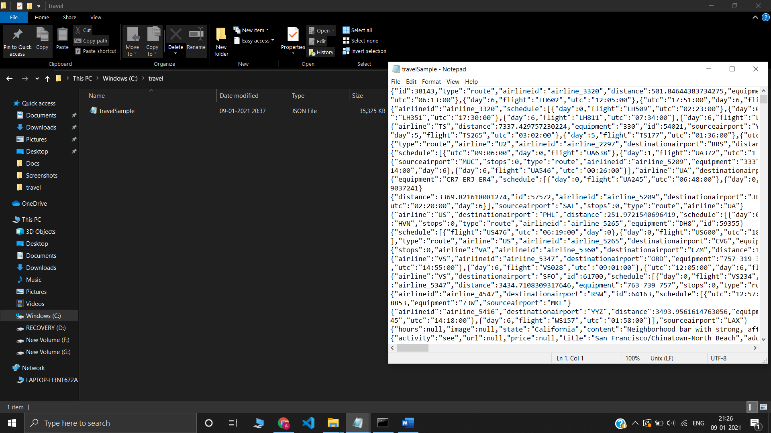

New Bucket (New-travel) where the data is imported

